**Soccer Stars: Quest for Glory - Design Document**

**Name:** Michael Coleman

**GMIT ID:** G00347650

**Email:** [G00347650@gmail.com](mailto:G00347650@gmail.com)

Contents

Research of Specified Game Genres: 2

Category 1: Shooters 2

Category 2: Platform Games 3

Traditional Games e.g. board games 4

Genre Choice Reasons: 4

Game Design: 4

Story Concept: 4

Front End: 4

In-Game Menus: 5

Control Mechanisms: 5

Menus/Screens: 5

The Game: 7

Game Intro: 7

Game Ending: 8

Character Design/Graphical Style: 8

Gameplay during levels: 8

Level progression, reward systems and winning conditions: 9

Difficulty Increase: 10

# 

# Research of Specified Game Genres:

Category 1: Shooters – The shooting genre of games is a very expansive genre due to the almost endless possibilities available to game development companies, 2D shooting games come in different forms such as vertical shooters e.g. “Space Invaders” - This game was popular due to it being a massive change in gaming at the period of its release as it was the first ever fixed shooter resulting in it being a fresh change in the gaming community. It also was named the top rated arcade game by the Guinness World Records (see in article under heading “Revolutionary Impact” - <https://www.bbc.com/news/technology-22714047> ).However this genre has a very limited set of abilities that can be utilised for variation in gameplay for modern games. Similar to the vertical shooters only played horizontally is the Horizontal shooter genre e.g. “Aerial Assault” – A game by SEGA that was popular due to its really fast gameplay resulting in the user having to destroy multiple types of aircrafts while keeping themselves alive. Similar to vertical shooters, this genre too had some great popularity in early gaming but has since been overshadowed by the platform shooting genre with very little games being produced in these categories in recent times due to the similarity in games across both genres. ” Top-down shooters” e.g. “Hotline Miami” – A game which released in recent times winning many awards with highly rated reviews where the user has a Birdseye view of the game being able to shoot enemies. This was popular due to its story and arcade feeling gameplay. Another shooter genre is hybrids of the shooter and platform genres as mentioned above e.g. “Mega Man” – A game by Capcom which gained huge popularity for its run and gun style which has resulted in 35 major games being developed for the series since its original release - <https://www.thegamer.com/mega-man-every-game-ranked/> . This genre appeals to their audience through the use of fast gameplay (e.g. bullets being shot by both user and enemies etc…) as well as having a tactical aspect whereby the user must outsmart enemies to avoid being shot to complete the game. A great example of this is although not a 2D shooter, is the 3D Star Fox shooter series by Nintendo. The game takes only about two hours to complete, but death of the user results in the user having to restart from the beginning of the game ensuring users are smart with their decision making. This principle applies to most shooters however the consequences may not be as severe e.g. may just restart a level or at a checkpoint. Many users may also find shooters frustrating in a love hate relationship as they may get angry when they die, but upon turning off the game, may find themselves wanting to turn back on the game and play again due to wanting to win/succeed, this appeals to people of a competitive nature more so than a platformer would for example. This is why the platformer/shooter hybrid allows for merging of both types of gamers. In conclusion, Although the shooter genre of games has come under criticism from areas of the media due to pushing violence as a narrative, it still remains to be in amongst the most popular genres out there for gamers.

Category 2: Platform Games – Platform games allow for the most diverse gameplay of the 3 genres in my opinion. While shooters can be very different, the same concept applies throughout the genre. While platformers on the other hand, can range from a simple jumping game with enemies such as “Super Mario Bros” to a puzzle game such as the “Trine” series where users must use their environment to progress. This genre is popular due to the variety in gameplay as well as the challenging aspects which make learning the gameplay mechanics so fun to users, for example in the “Super Mario Bros” series of games, timing of jumps is critical but the user also has the option to take their time and ensure they complete the level or to do it quickly if they want a better time for the level completion. Aspects such as this allows for replay ability. The many sub genres of platform games make it almost impossible for game developers to run out of ideas and even to this day many 2D platform games are released by independent developers with great success e.g. “Little Nightmares”, “Ori and the blind forest” in an industry that is now dominated by open world games and ultra-realistic graphics. This can be seen by the popularity of the recent Nintendo switch console whose best-selling games are majority platformers e.g. “Super Mario Maker”. Also “Super Mario Bros” made in 1985 is still in the top 10 most selling video games of all time just goes to shows the popularity of this genre – source: <https://ie.ign.com/articles/2019/04/19/top-10-best-selling-video-games-of-all-time>.

Traditional Games e.g. board games - This is more of an open-ended genre, as there isn’t a specific style to each board game e.g. a chess game will differ completely to a game of “Monopoly”. While platformers all have the same progression system e.g. the character progresses and the level changes with them. Board games are an out and out tactical game and grab their user’s attention by forcing them to user their intelligence to outsmart an AI or another person if playing a multiplayer game. Although these games have large fanbases, I think they can only hold a casual user’s attention for a few games e.g. pop in and play 1 or 2 games to pass the time as many of these games can feel repetitive, for long term players they target a more dedicated audience than the other genres as although the games may appear simple on the outside, many of these games have a steep learning curve requiring the users to spend hours practising in order to become really good at the game. Many of these games have different levels of AI in order to help the user’s progression too. Some of these AI’s are almost impossible to beat. For example, in the video game “GO”, the world champion was beaten by an AI made by Google in 2017. source - <https://www.bbc.com/news/technology-40042581>.

# Genre Choice Reasons:

The genre of game I have chosen is a hybrid of a platform game and a shooter, giving the user multiple choices in terms of gameplay. The user will have the option to both play the game as a jumping platformer and as a shooter. I have chosen this to allow users the ability to express themselves and allow replay ability to the game. It also allows the game to appeal to larger audiences as gamers of the platform genre may find the hybrid idea interesting and vice versa with fans of the shooter genre. The games that inspired my idea concept the most is “Mega Man” and “Super Mario Bros” as the player can both progress via killing of enemies and platform progression via jumping with many parts of the game requiring use of both to ensure progression. Another reason for choosing these games as a basis to work off is that these games were among my favourites when growing up as I owned all the old consoles which my brother had and I spent countless hours trying to complete these sorts of games.

Mega Man Gameplay - <https://www.youtube.com/watch?v=b-DMQ19h1p4>

Super Mario Bros Gameplay - <https://www.youtube.com/watch?v=rLl9XBg7wSs>

# Game Design:

Story Concept: The concept of the story for my game is a football team has had their trophies stolen and need to progress through levels against enemies in order to win them back (killing of enemies should be optional to the user except for the final boss battle). They can use footballs as their weapons (can be fired at enemies) or can progress by jumping around enemies and using platforms to avoid them. This all must be done while the enemies shoot projectiles at the user when they are within a certain range. The user will be the team’s captain as he takes on the role of the hero who will fight for his team to regain their trophies.

## Front End:

* A simple title screen displaying the logo and press any key to continue.
* Character colour customization screen. Give three options to choose from.

## In-Game Menus:

* Pause Menu with options for volume control, reset level and exit game functions. Also display user progress for collected items.
* Level transition screen.
* Ending scene congratulating user with credits.

## Control Mechanisms:

* The user should be able to move their character using the A and D characters along the horizontal axis in order to progress through levels.
* The user should be able to jump their character up via a jumping action which will be carried out using the spacebar key, this is to allow the users to jump over holes in the ground terrain as well as jump on platforms to avoid enemies etc. Note: If user falls down a hole, it will result in instant death no matter what health the user currently has (Concept adapted from super Mario bros).
* The user should also have the ability to run faster by pressing the R key in accordance with their directional key they are currently pressing. Note: if R pressed while user is stationary nothing should happen. The faster running can be animated by upgrading the frames per second (FPS) of the regular character moving animation.
* The user should also have an option to crouch using the left shift key where they bend over to have the option to avoid projectiles shot at them by the enemies.
* The user should have the option to fire their own projectiles using the Q key. This should show the player shoot/kick a football using a kicking animation in which a football is kicked and fired as a projectile in the direction the user is facing. There should be a cooldown period so the user cannot spam projectiles.
* The user should have three hearts per level, when an enemy makes contact with the user using a projectile they shoot or user makes direct contact via running into the enemy, then the user should lose a heart. Note: When all hearts are gone, the user should die and have to restart the level. Users hearts should also be displayed on screen and hearts should be greyed out when user has taken damage.
* The user should also be able to find water bottles around the map which should regenerate one heart of health per each collected. Note: If user is already at full health no increase should take place.
* User should be able to collect 4 cards in a level which when all collected per level gives the user a heart bonus going into the next level.

## Menus/Screens:

During my research looking at the games I have based the games on I realised many of the old games, if not the majority of these games’ menus are just pausing the gameplay with no options, but I think for a game now, options for a user is vital e.g. reset level, volume settings etc.

The first menu the user should encounter is one with the logo for the game followed with a “press any key to continue” button underneath the logo.

Upon pressing any key, the user should be given another menu screen where they get to choose their characters colour. Then upon selecting a colour they should be dropped into the main cutscene with their character of choice.

The user should have the ability to pause the game and bring up the menu using the E key. The user should have the option to control the volume for both the music in the background as well as in-game sound effects e.g. jumping/death noises, bullet noises, level completion noises etc, as user may not want to hear music/sound effects. Another option to the user should be the restart level as well as to Exit game (This should be followed with a “are you sure? All progress will be lost” screen, where user can say yes or no.) The user should also be able to view the controls of the game by selecting a controls panel where all user controls should be displayed in case the user forget the controls (mistakenly left out of sketch below). In the pause menu indicators with the cards not collected by the user should be greyed out and upon collecting a card it should be appear ungreyed with the colour of the card collected shown for the user in the pause menu screen so they know which cards they have/ have not collected for the level.

There should also be a level transition screen letting the user know they have completed the level and show them they are moving onto the next.

Game should end with a congratulations screen for the user and have a short credit’s screen. With designer and developer names.

# The Game:

## Game Intro:

The game should begin after the user has selected the customization choice for their character e.g. choice of character colour screen. The game should start with a small cutscene (as simple as a camera change) showing the team celebrating with their newly won trophy (along with their other trophies they won throughout the year), when they are stolen from them. The user should then be placed into the level and be shown a simple tutorial of how to play the game. i.e. show them how to run, jump, crouch, shoot etc.

## Game Ending:

The game should end with a boss battle encounter in which the user must defeat the boss to complete the game. The boss should fire projectiles much quicker and in bursts which the user must avoid. There should be platforms which the user can use to hide from these projectiles, but these should not allow the user a clear shot of the boss, meaning they must have to time their shots as well as take the risk of being hit in the process.

## Character Design/Graphical Style:

The game should have a pixelated style to it, reminiscent of the old games played on consoles such as the NES (Nintendo Entertainment System) and SNES (Super Nintendo Entertainment System). This pixelated genre is still very popular among platform games as it gives gamers a nostalgia trip when playing. Examples of characters shown below.

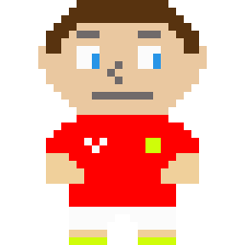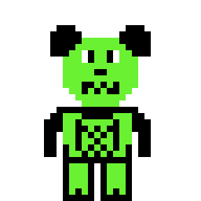

## Gameplay during levels:

After completion of the tutorial, the user should be allowed to progress through the first level. The levels will consist of a mixture of platforms which need to be jumped on and holes in the ground which need to be jumped over to ensure progression. As well as enemies shooting projectiles at the user in the process. The player will need to progress each level before moving onto the next level. The user can also collect cards scattered throughout the map though that is not necessary.

below are some sketches of an example of gameplay

Here are examples of similar platform progression below from “Super Mario Bros”

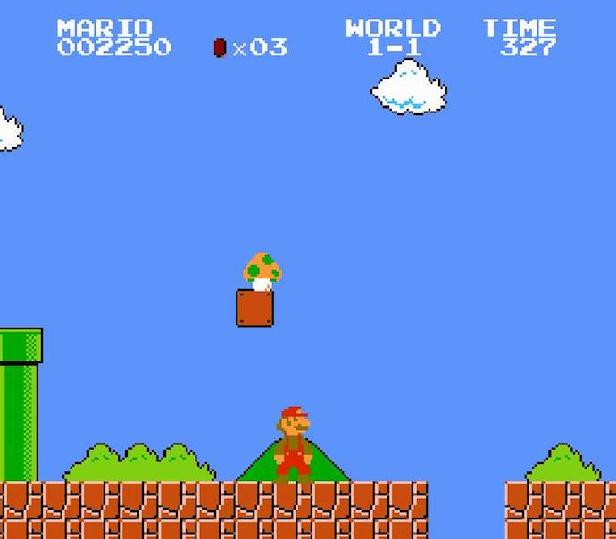

## Level progression, reward systems and winning conditions:

The user can progress each level by collecting the trophy at the end of the level, this can be done by showing the player lift the trophy and celebrate with it and run off screen and then continue to the next level via a simple transition screen.

The reward system includes placement of water bottles throughout the level which upon collection will result in the user regaining some health allowing them to recover from earlier mistakes as they continue progression through the level. Another reward system for the user is the collection of football cards scattered throughout the map. Each level should have 4 cards to collect, when they user collects all four cards in a level, they should have an extra heart for their health in the next level, e.g. if user collects all cards in level 1, they will have 4 hearts when they go into level 2, while failure to find all four cards would result in user remaining with 3 hearts in level 2. The user should be able to view cards collected for a level in the pause menu. This card collection allows the user the option of exploring the Gameworld and be rewarded for doing so by having more health to deal with encounters with enemies later in the game.

Winning condition is simple for the user, simply progress through the level without dying and you can continue. Collection of all cards or killing of all enemies should not be required for progression. Note: Player must defeat boss to win the game, as upon killing boss, the final trophy should drop for user collection.

## Difficulty Increase:

The game should increase in difficulty not alone upon progression to a new level, but even as the user progresses through the level itself via increase in enemies, more platforms and holes for the user to have to jump over. The user, as previously stated, has the ability to regain health, this should also become harder by making the water bottles less frequent for pick up by the user to regain health as well as making the water bottles increasing harder to get to e.g. putting them on a platform where enemies block the path to it or on a platform which is hard gotten to and a mistimed jump may result in falling off the game world and death, giving the user a “risk for reward” system. Enemies will increase in difficulty every level i.e. taking more hits to kill them e.g. level 1 – 1 hit to kill, level 2 - 2 hits to kill etc. At the end of the last level the user should encounter a boss also which should be sufficiently harder to beat as the boss can fire more rapidly and will have a lot more health than normal enemies.